Primary Alpha, Transformed Beta and Low Cycle Fatigue

Prof Dipankar Banerjee and Prof Satyam Suwas

**Background:**

Engineering titanium alloys consist of microstructures that consist duplex structures of equiaxed, primary alpha and transformed beta or in beta-solution-treated materials, which consist of lath alpha

Alpha + Beta Heat Treated Structures

In a recent publications [1, 2] we have shown that primary, equiaxed alpha can exist both the BOR and in non- BOR relationship with surrounding beta grains in an alpha+beta processed microstructure. We also note that such primary alpha grains need not be completely isolated from other such grains but can remain in contact with each other in local areas. A simple schematic description of these possibilities is shown in Figure1.This aspect of the crystallographic relationship with of equiaxed, primary alpha with surrounding beta grains or alpha/alpha grain contact has not been examined in any great detail in earlier work, particularly since it has been commonly believed that such recrystallized equiaxed alpha with not share a BOR with surrounding beta grains.

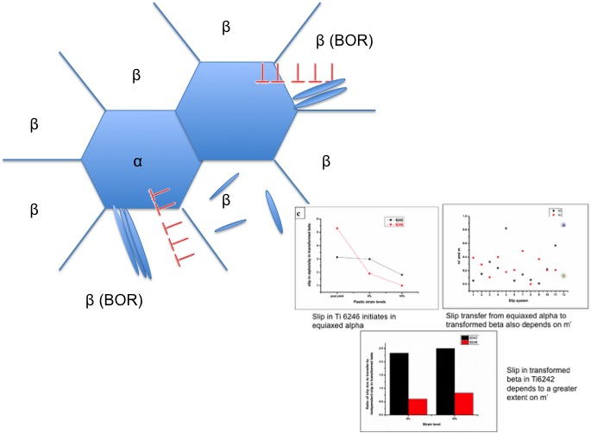

Figure 1

Such local microtexture can potentially affect secondary alpha formation. In addition, since the BOR places several slip systems in alpha and beta in close geometrical parallelism, local microtexture as defined above will also affect slip transfer out of the alpha phase into surrounding beta grains depending upon whether these grains are in BOR with surrounding beta grains or not, as has been recently demonstrated by us in Ti6242 in work supported by P&W [3]

Beta Heat Treated Structures

As an alternative heat treatment, particularly in cast structures, beta heat treatment in Ti6242 can generate coarse lamellar structure in the form of colonies or basket weave structures. Slip lengths in colony structures are determined by the colony size, since each colony consists of similarly oriented alpha laths in the BOR with thin retained beta. There had been little understanding of slip lengths in basket weave structures, until recent work supported here by P&W. We have shown [4] that basket weave structures consist of groups of alpha laths which share a common [11-20] axis while being BOR related to the retained beta (see Figure 2). The overall size of such groups is not very different from colony sizes within prior beta grains. Since such groups share a common slip ‘a’ slip direction and also have {10-11} and (0001) planes parallel within such a group, slip on these planes extend across the entire length of such alpha groups and define the slip length in basket weave structures

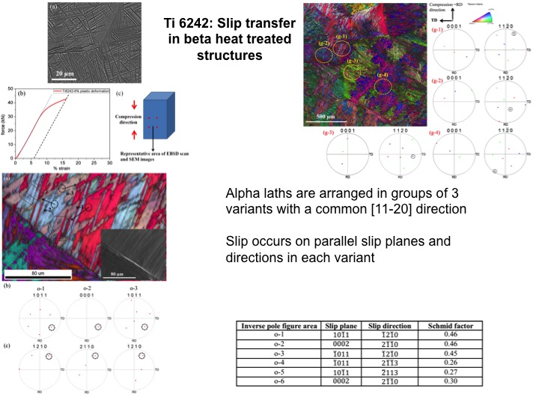

Figure 2

Against this background we propose the study of the statistics of such distributions in alpha +beta processed and beta processed microstructures on low cycle fatigue life in Ti6242

References

1. Shanoob Balachandran, SharathKumar,  Dipankar Banerjee, [On recrystallization of the α and β phases in titanium alloys](http://www.sciencedirect.com/science/article/pii/S1359645417302902), Acta Materialia , 131, 432-434

2. Banerjee, Dipankar; Pilchak, Adam L; Williams, James C, Processing, structure, texture and microtexture in titanium alloys,

3. Arunima Banerjee, ME Thesis, Materails Engineering Department, Indian Institaiute of Science, 2015

Banerjee, Arunima; Balachandran, S; Suwas, Satyam; Banerjee, Dipankar, Proceedings of the 13th World Conference on Titanium, Ed Vsisht Venkatesh et al, TMS (The Minerals, Metals & Materials Society, 1095-1101, 2016.

4. Abhishek Tripathi, Biswaranjan Dash, Satyam Suwas and Dipankar Banerjee, unpublished work IISc, 2016.

**APPROACH AND STATEMENT OF WORK**

TASK 1: 3 heat treatments in alpha +beta and beta processed condition to generate different statistics of microstructure and microtexture (P&W may advise on specific heat treatments)

TASK 2: Large and local area EBSD to generate an a) adequate statistical description of primary alpha grains in terms of alpha/alpha grain contact b) the statistics of primary grains that are BOR related to the surrounding beta c) secondary alpha texture and its correlation with primary alpha texture d) statistics of colony size and basket weave group size for different heat treatments

TASK 3: Generation of LCF data: P&W to advise on a) whether stress controlled or strain controlled b) strain/stress levels c) RT or higher temperature d) R values and cycle waveform

TASK 4: a) First cycle slip analysis with slip offsets or digital image correlation to determine initiation of slip b) slip analysis after quarter life or half-life to determine development of damage c) fracture initiation

Task 5: data correlation with fatigue life

**4. DELIVERABLES**

**Deliverables for 1st Year:** Tasks 1, 2,

**Deliverables for 2nd Year:** Tasks 3 and part 4

**Deliverables for 3rd Year:** Part Task 4 and 5

**5. Schedule**

Total duration of the project is 3 years with yearly release of fund.

|  |  |  |  |  |  |  |  |  |  |  |  |  |
| --- | --- | --- | --- | --- | --- | --- | --- | --- | --- | --- | --- | --- |
| Technical Tasks / Months after Project Initiation | 1-3 | 4-6 | 7-9 | 10-12 | 13-15 | 16-18 | 19-21 | 22-24 | 25-27 | 28-30 | 31-33 | 34-36 |
| TASK 1: Heat Treatment and preliminary microstructure |  |  |  |  |  |  |  |  |  |  |  |  |
| TASK 2: EBSD analysis |  |  |  |  |  |  |  |  |  |  |  |  |
| TASK 3: fatigue tests |  |  |  |  |  |  |  |  |  |  |  |  |
| TASK 4: Slip and fatigue damage studies |  |  |  |  |  |  |  |  |  |  |  |  |
| TASK 5: Analysis |  |  |  |  |  |  |  |  |  |  |  |  |

.

**6. Cost**

|  |  |  |  |
| --- | --- | --- | --- |
| **Budget Head** | **1st Year (USD)** | **2nd Year**  **(USD)** | **3rd Year**  **(USD)** |
| Total project cost including overheads | 65000 | 55000 | 50000 |

*Total duration of the project is 3 years with yearly allocation and release of fund by PW.

**ATTACHMENT 2A**

**DISCLOSURE INFORMATION**

# Prof. Dipankar Banerjee and Prof Satyam Suwas

**1 Current Involvement with US Government and Industry Funded Projects:**

We will not provide this information but certify that there is no conflict of interest of any kind with any other p[rojects in which the investigator is involved and that no other agency , private or public is funding or has been approached for funding this study

**2. CLASSIFICATION OF GOVERNMENT FUNDED ACTIVITY:**

Not applicable in view of above

**3. CONSULTING ACTIVITY FOR OTHER UTC BUSINESS UNITS:**

Nil

**4. PREVIOUS UTC EMPLOYEES:**

Nil

**5. Country of Citizenship:**

India

**ATTACHMENT 2B**

**DISCLOSURE INFORMATION**

# Prof. Satyam Suwas

**1 Current Involvement with US Government and Industry Funded Projects:**

We will not provide this information but certify that there is no conflict of interest of any kind with any other projects in which the investigator is involved and that no other agency , private or public is funding or has been approached for funding this study

**2. CLASSIFICATION OF GOVERNMENT FUNDED ACTIVITY:**

Not applicable in view of above

**3. CONSULTING ACTIVITY FOR OTHER UTC BUSINESS UNITS:**

Nil

**4. PREVIOUS UTC EMPLOYEES:**

Nil

**5. Country of Citizenship:**

India

**ATTACHMENT 2C**

**DISCLOSURE INFORMATION**

# Students name not known at this time

**1 Current Involvement with US Government and Industry Funded Projects:**

We will not provide this information but certify that there is no conflict of interest of any kind with any other p[rojects in which the investigator is involved and that no other agency , private or public is funding or has been approached for funding this study

**2. CLASSIFICATION OF GOVERNMENT FUNDED ACTIVITY:**

Not applicable in view of above

**3. CONSULTING ACTIVITY FOR OTHER UTC BUSINESS UNITS:**

Nil

**4. PREVIOUS UTC EMPLOYEES:**

Nil

**5. Country of Citizenship:**

India